-------------------------------------------------------------------------------------------------------------------------------NAME: ARCHANA DEVI.P
REG NO: 192521192
COURSE: SOFTWARE TESTING
CODE: CSA0923
LAB PROGRAMS
Question 19: Compound Interest Using Functions and Junit

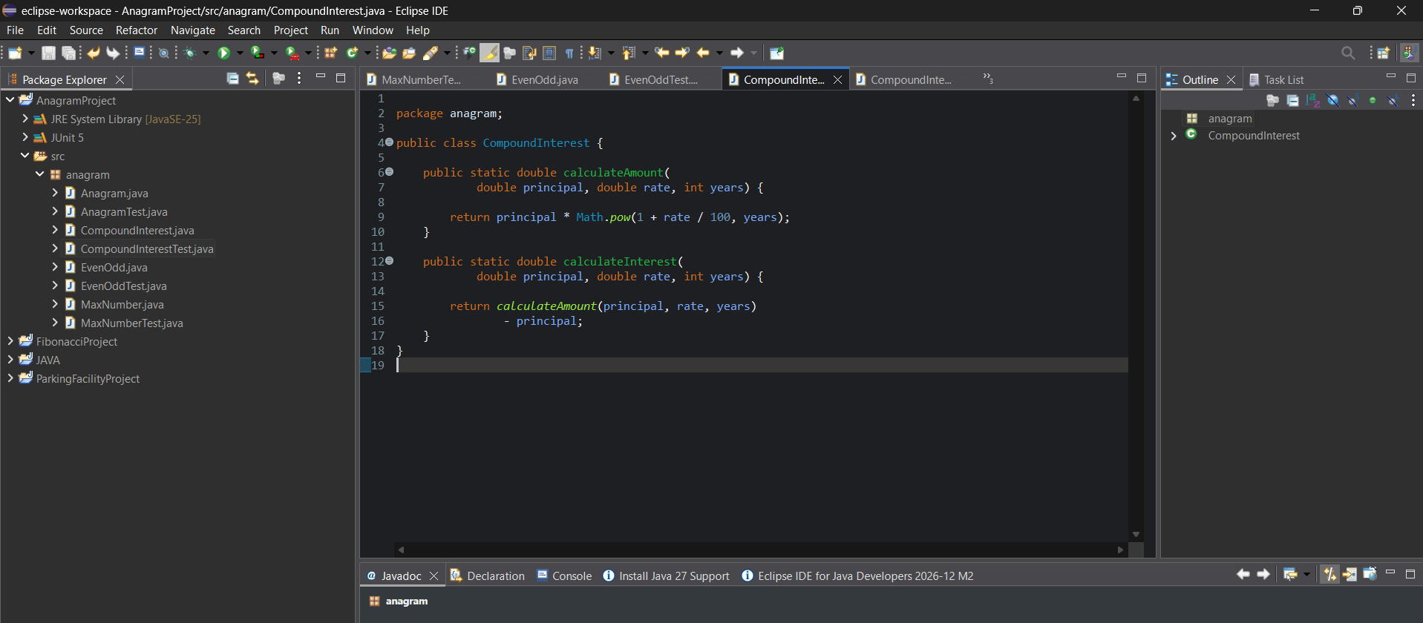

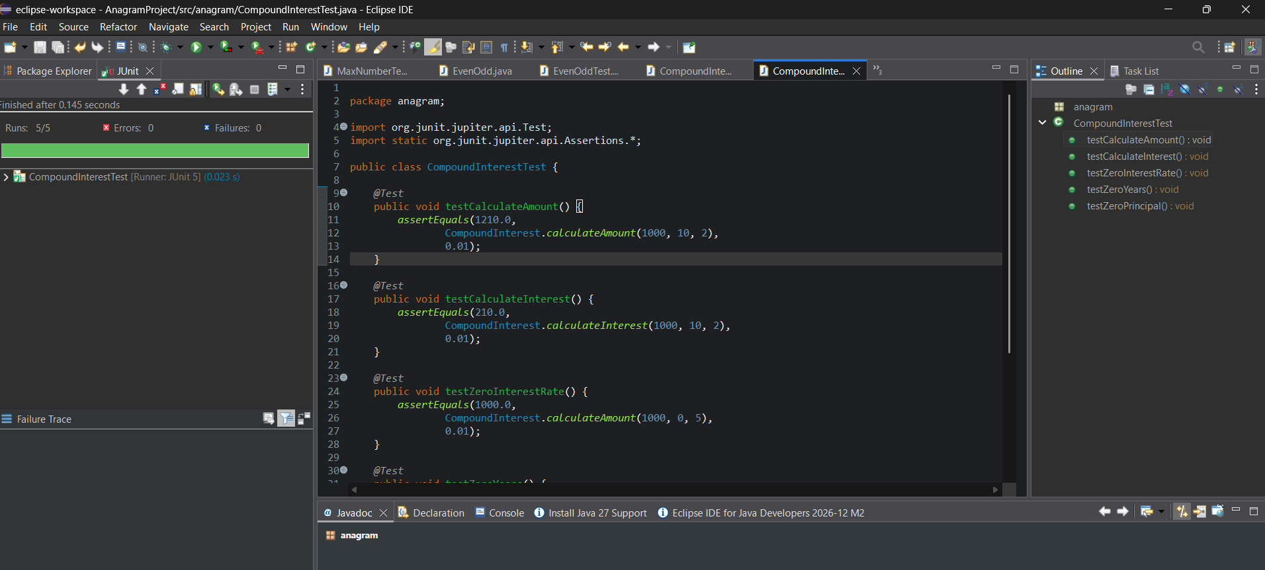
White-box testing
The tests check:
- Normal compound interest calculations.
- Calculation of interest separately from the final amount.
- Zero interest rate.
- Zero years.
- Zero principal.
These test cases check normal operation and important boundary conditions.
Result
The compound interest program was implemented using Java functions. JUnit assertions verified the final amount and interest calculations, including boundary cases. All five tests should pass if the code is entered correctly.

